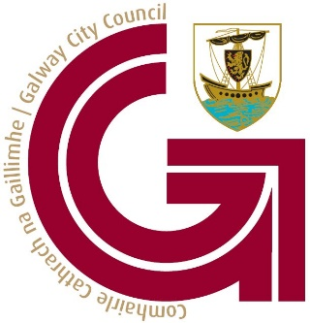
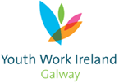

Galway City Comhairle na nÓg
1st December 2021
Report September to December

Committee
- From September to date we have been holding the committee meetings in person. We were using the outdoor space in the Ardilaun Hotel and then moved to the Atlantic Language College in Fairgreen Road for the past few weeks. An accessible meeting space to accommodate the committee is a big issue for us. We hope to continue to meet in person while it is possible.
- We will host a welcome meeting with those who expressed interest in joining the committee on Monday 6th of December following on from the AGM. Our final meeting of 2021 will take place on Monday 13th.
- 4 of our current committee will be stepping back from the committee due to their Leaving Cert exams taking place in 2022.
- Ruby will be stepping down from her role as National Executive Representative as her two-year term will be completed following Dáil na nÓg (which has been postponed to March 2022). The new representative will be chosen at the committee meeting on Monday 30th of November.

Topic
- The committee are continuing to work on the topic of mental health and invisible disabilities. The coordinator attended a workshop on mapping Galway City and how accessible it is for people with disabilities (both physical and invisible) from this we have created a link with Access 4 All Galway and discussed the possibility of an Access 4 All Galway Youth Committee. This is something the Comhairle Committee will try to support.
- Some committee members have met researchers in NUIG Child & Family Research Centre to work on the focus group on invisible disabilities. We will begin promoting the focus group with young people in the coming weeks and hope to carry out in early 2022.
- At the AGM, we carried out workshops on ‘Accessible Galway/Youth Facilities- Physical and Sensory Accessible Youth Spaces ‘and a mental health workshop ‘Mental Health - Design a mental health toolkit’.
- We had hoped to host an in-person event on the 26th of November to lead on from the AGM workshop, but unfortunately due to rising COVID numbers we had to postpone to 2022.
- We will be hosting a podcast interview with members of Galway County Comhairle na nÓg on body image and impact on mental health in December.

Other activities
- On the 1st of October some committee members participated in a virtual Sleep Out for Simon with young people from Youth Work Ireland Galway.
- The committee are also participated CVA (Citizen Voice Action) workshops with the SAUTI Youth Project in October and will participate in activities that relate to the topic around accessibility.
- As part of the Development Fund to engage stakeholders, the committee had planned an in-person event for November, but this has been postponed to 2022.
- The committee presented on the work of Galway City Comhairle na nÓg to the CYPSC on the 19th of November.
- The outreach education officer in Galway City Museum is linking with the committee on an exhibition called Treaty 100, looking at Galway connection with the Anglo-Irish Treaty.
- A draft survey has been designed as part of the stakeholder engagement plan, which will reach out to organisations who we hope to engage with as part of the work of Galway City Comhairle na nÓg committee. We hope to be able to share the survey in early December.
AGM
- The AGM took place on the 11th of November, it was online again this year as recommended by the DCEDIY. All secondary schools in Galway City participated in the AGM.
- The topic voted for the committee to focus on was Accessible Youth Spaces. We will continue to work on the previous topic
- Goodie bags were sent out to all young people who participated in the AGM.
- A letter will go out to all schools to thank them for their continued support
- Thank you to the Youth Workers who supported the AGM and co-facilitated the workshops with the committee members.

Coordinator
- The coordinator will participate in digital facilitation training on the 10th and 17th of December.
- The Comhairle na nÓg Annual Report for 2021 and the Funding Request for 2022 have been issued with completion in early January.

For more information on the work of Galway City Comhairle na nÓg, please follow the social media pages.
https://www.facebook.com/GalwayCityComhairleNanOg
https://www.instagram.com/galwaycitycomhairle/

