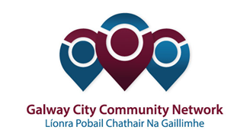
Tuairisc/Reporting Template for
Galway City Community Network Representatives

Please complete and email to communications@gccn.ie
at your earliest convenience, preferably one week after the meeting
and no later than two weeks.

Cruinniú / Name of Meeting

Ionadaí LPCG (glacadóir - nótaí) / Name of GCCN Rep (note-taker)

Dáta & Suite / Date & Location of Meeting:
I láthair / Attendance | Present  ----------  Council:  Community:  In Attendance:

Príomhphointí pléite / Key Issues Discussed:

Socruithe déanta / Key Decisions Made:

Gníomhaíochtaí / Action(s) required from GCCN:

Dáta don chéad chruinniú eile / Date of next meeting :

Moltaí breise /

Any Other Comments:

