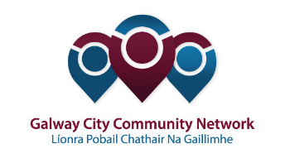

Galway City Community Network
The Public Participation Network in Galway City
GCCN Representative Nomination Form 2019
Name
Nominating Organisation
The Pillar of your group/organisation  (mark as appropriate) | - Social Inclusion
 | - Environment
 | - Community/Voluntary
Structure you want to represent GCCN on  (mark only one option) | SPC1: Housing and Social Inclusion
 | - Community/Voluntary
 | - Social Inclusion
 | SPC2: Planning
 | - Community/Voluntary
 | - Environment
 | SPC3: Economic, Community and Cultural Development
 | - Community/Voluntary
 | - Culture
 | SPC4: Transportation
 | - Community/Voluntary
 | - Environment
 | SPC5: Climate Action, Environment, Recreation and Amenity
 | - Community/Voluntary
 | - Social Inclusion
 | - Environment
 | Local Community Development Committee
 | - Environment
 | - Social Inclusion
 | - Voluntary
 | Joint Policing Committee
 | Galway Sports Partnership
Why you are interested in representing GCCN
Please outline your relevant experience
Please give details on how you meet the criteria for GCCN Representation
Do you understand that you are committing to the role and responsibilities of GCCN representatives as outlined in the Representatives’ Charter? |  | Yes | No
To be returned to communications@gccn.ie before Friday, 13th September 2019.

To be drawn from GCCN members with an interest in arts and culture.
To be drawn from GCCN members with an interest in community safety.
To be drawn from GCCN members with an interest in sports and recreation.
As outlined in GCCN Representative Elections 2019 – 2024: Guidelines and Information.
https://galwaycitycommunitynetwork.ie/wp-content/uploads/2018/03/reps-charter-661x1030.jpg

