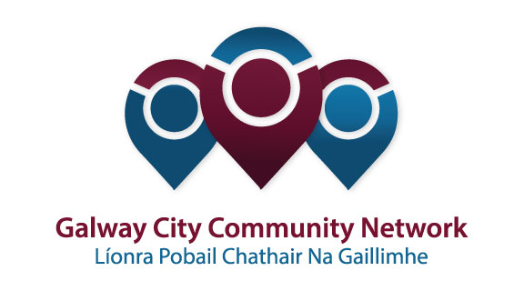
Tuairisc/Reporting Template for Galway City Community Network (GCCN) Reps

Please complete and email to info@galwaycitycommunitynetwork.ie
Cruinniú /Name of Meeting | Comhairle na nÓg, Galway City Steering Group
Ionadaí FPCG (glacadóir - nótaí)  Name of GCCF Rep (note-taker) | Fiona Jennings
Dáta & Suite  Date & Location of Meeting: | 6/2/19, Training Room, Galway City Council
I láthair/ Attendance | Jakub Kostunski, Galway City Comhairle na nÓg  Deirdre Bermingham, Youth Work Ireland Galway / Galway City Comhairle na nÓg Co-Ordinator  Caitríona Morgan, Ruth Flynn, Mairéad Lyons, Galway City Council  Morgan Mee, CYPSC  Irene Murphy, Youth Work Ireland Galway  Deirdre Treacy, Galway Simon  Fiona Jennings, GCCN
Príomhphointí pléite / Key Issues Discussed:

- The topic for 2019 is homelessness (youth homelessness) and the Comhairle will be working closely with Galway Simon to find out more about the issues affecting young people in Galway City. The Comhairle are engaging in a series of information gathering and advocacy training workshops to support their work in this area. The plan is to train the Comhairle as advocates to raise awareness of youth homelessness amongst their peers.
- Crinniú na nÓg – Saturday, 15 June 2019. Open to all groups who would like to submit a proposal by end of February on the template supplied. There is approx. €15k in funding available (info supplied).
Socruithe déanta/ Key Decisions Made:

- Steering group to feedback ideas/comments to Deirdre Bermingham on the chosen topic by Wednesday, 13 February.
- Crinniú na nÓg Proposals due by Wednesday 27 February 2019.

Gníomhaíochtaí
Action(s) required from GCCN:

- If GCCN members have ideas for Comhairle’s chosen topic this year can they forward to the rep by Friday 22 February so the Comhairle can consider them in their planning for the year that would be appreciated.
- Please forward details of Crinniú na nÓg to GCCN members should they wish to submit a proposal.

Dáta don chéad chruinniú eile  Date of next meeting : | 1 May 2019, 4pm
Moltaí breise /Any Other Comments: Reminder from Galway City Council that nominations for the Mayor’s awards is now open.

