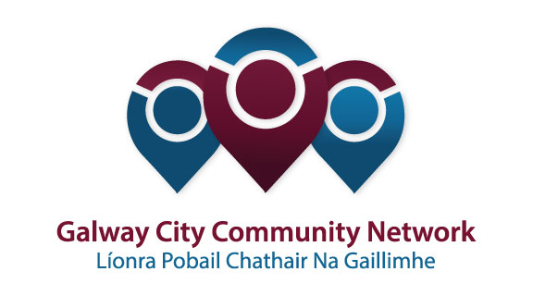
Tuairisc/Reporting Template for Galway City Community Network (GCCN) Reps

Please complete and email to info@galwaycitycommunitynetwork.ie
Cruinniú /Name of Meeting | Transport SPC
Ionadaí FPCG (glacadóir - nótaí)  Name of GCCF Rep (note-taker) | Derrick Hambleton
Dáta & Suite  Date & Location of Meeting: | 27th April 2018
I láthair/ Attendance | In attendance John Walsh, Chairman, Mark Lohan, Frank Fahy, Pat Hardiman, Peter Keane (late) + Council Reps
Príomhphointí pléite / Key Issues Discussed:

As per agenda.

First item – a minutes appreciation of committee member: Dr. Chris Coughlan. I offered the GCCNs respects on behalf of all our members.

- A presentation was given by Hugh Cooney of Bleeper Bike, a company seeking to supply a service of untethered rental bikes in Galway. Among the questions asked was, who would be responsible for providing the additional Sheffield (type) bike stands? Would the bikes simply be left tethered to lamp posts, fences, railings etc.
- Daithi Flood gave a presentation on the level of progress made on the Western Greenway. It is suggested that there will be a 3m shared surfaced width. There is a full consultation team in County Buildings with work ongoing in discussion with all landowners though progress is slow.
- Information was given on the progress of N6 Ring Road, which is expected to go to ABP in July. A workshop to discuss proposals for removal of the Browne Roundabout is to be organised for Councillors first off, at which point I complained about GCCN exclusion, but was told that it was for councillors only with the public involved at a later date. Dublin Road bus lane developments were also discussed.
- The removal of the Kirwan roundabout at the Headford Road is at Part 8 Planning, while CPO land acquisition is the next issue!

Socruithe déanta/ Key Decisions Made:
No decisions made
Gníomhaíochtaí
Action(s) required from GCCN:
None
Dáta don chéad chruinniú eile  Date of next meeting: | Special meeting on July 20th.
Moltaí breise /Any Other Comments:
Meeting poorly attended by councillors, with short meeting a result

