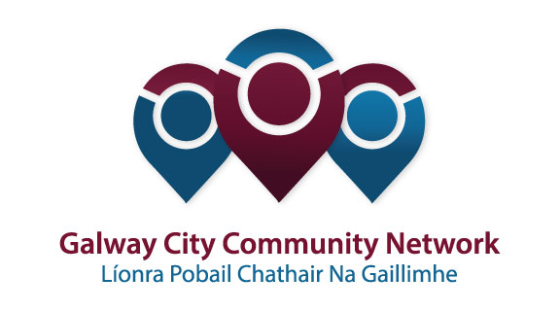
Tuairisc/Reporting Template for Galway City Community Network (GCCN) Reps

Please complete and email to info@galwaycitycommunitynetwork.ie
Cruinniú /Name of Meeting | Housing Strategic Policy Committee
Ionadaí FPCG (glacadóir - nótaí)  Name of GCCF Rep (note-taker) | Diarmaid O’Sullivan and Paul Hargaden
Dáta & Suite  Date & Location of Meeting: | Galway City Council. Friday 22nd February 2018
I láthair/ Attendance | Cllr Mark Lohan, Cllr. Declan McDonnell, Cllr. Michael Crowe Cllr. Mike Cubbard, Cllr. Niall McNeilis, Cllr Mairead Farrell  Dermot Mahon, Sharon Lawless, Helena Martyn, Siobhan Donoghue, (All Galway City Council)  Diarmaid OSullivan, Paul Hargaden (Galway City Community Network)
Príomhphointí pléite / Key Issues Discussed:

Housing Supply/Delivery Update
- Ballymoneen Phase 1 is on schedule with 14 units due to be delivered by April of this year. Hope to be on site with Phase 2 by Sept. / Oct. 2018. This will deliver a further 78 units.
- Ballyburke PPP Scheme was published in Feb 2018 for 74 units.
- Phase 1 for Ballybane has been approved (50 units) with a second phase of 7 units.
- Infill site in the Westside is being progressed though a number of concerns were raised.
- Concern re. length of time that Part 8 will take.
- Concern re. lack of consultation with the residents living in the area.
- Extra meeting sought to push through the Part 8, possibly an extra meeting in July?

- AHB’s have 180 units in the pipeline and are progressing a further 200 units
- The target for new units for the city by 2021 is 1,100.
- 300 built on owned land
- 300 built on purchased land
- 400 delivered by AHB’s

Note: The next two years will be a struggle until new units are delivered. The LA will need to acquire land as they do not own enough land in the city.

Proposed Amendments to Scheme of Allocations, 2017 (Copy Attached)
- Please see note in Section 6.3. The Reps raised the issue of communication re. Allocations with AHB’s and that this needed to be improved. A discussion took place on the level of cooperation required when dealing with very difficult cases.

Choice Based Lettings
- Choice Based Lettings will be rolled out in Q2. GCC will be exploring options of how to move this forward and a briefing will be offered to Councillors in the near future. Units will be advertised electronically. Each applicant will have a log in, pin no. etc. and can bid if they chose to.
- Older Persons, Members of the Travellers Community and People with a Disability may be excluded from the electronic process.

Housing Needs Assessment
- The HNA is an annual event and will conclude in June 2018. Selected applicants will be contacted. GCC awaiting further detail from the Dept. Staff attended training last year. It is very important that people return the information, if the information is not returned then people will be removed from the list.
- 2017 - Over 2,000 people on the Housing Waiting List.
- RAS and HAP recipients are not included on the Housing Waiting List.

Homeless Report and Update/West Region Homeless Action Plan 2018-2021

- Currently 24 Families in Emergency Accommodation, 15 in Transition.
- In Galway City 161 people registered as homeless. 12/15 people presented each night during the ‘Emergency Cold Weather Response’. This finishes on April 3rd. (31 additional beds were made available in total).
- Diarmaid went through the detail of the GCCN Housing Event, including the programme for the day. He invited all those present to attend.
- Difficult to find HAP properties at present, the maximum rent thresholds are too low. Some families from the County are applying to the City as the threshold is higher.
- Transitional Houses are being used for larger families as this situation would prove very difficult to manage in a hotel scenario.
- We are facing into a difficult summer in terms of accommodation for homeless families.

- All service providers will be consulted during the preparation of the Western Region Homeless Action Plan. No definitive timeline was given. Currently waiting on guidelines to be issued from the Department of Housing.

Estate Management Policy- Overview
- Sharon introduced the new Estate Management Policy. Further consultation will take place over the coming weeks. The docs will be circulated before the next SPC meeting. Outline attached.
AOB

- Waiting on the Dept. to issue guidelines on the Affordable Housing Scheme which has yet to be announced. The LA will take on equity in the property to make the property affordable. Specific sites/areas are to be developed but as yet, detail is not available. It was decided to call a special meeting to move this forward.
- There is a new Home Loan available. This is not a loan from the LA but rather is managed centrally. Contact number is 051 349720 (National Helpline). 10% deposit is required, 2 x letters of refusals from other lenders and loan is available up to a max house price of €320,000 (loan of 288,000).
Interest rates are set at 2.2% over 30 years. So far 36 applications have been received.
- Recruitment is currently taking place for 2 Social Workers, 1 Vacant House Officer, 1 HAP Officer and several outdoor workers.

Socruithe déanta/ Key Decisions Made:

- It was agreed that a special meeting should be called to discuss the new Affordable Housing Scheme.

Gníomhaíochtaí
Action(s) required from GCCN:

Dáta don chéad chruinniú eile
Date of next meeting :
Moltaí breise /Any Other Comments:

