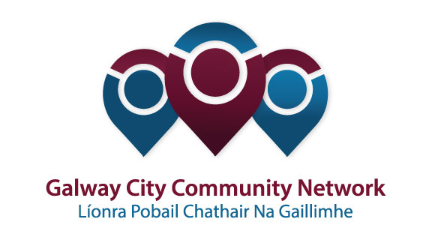
Tuairisc/Reporting Template for Galway City Community Network (GCCN) Reps

Please complete and email to info@galwaycitycommunitynetwork.ie
Cruinniú /Name of Meeting | Economic Development, Enterprise Support & Culture SPC
Ionadaí FPCG (glacadóir - nótaí)  Name of GCCF Rep (note-taker) | James Coyne
Dáta & Suite  Date & Location of Meeting: | 5th October 2017
I láthair/ Attendance
Príomhphointí pléite / Key Issues Discussed:

The SPC Meeting took place on 5th Oct 2017 and was chaired by Cllr. Padraig Conneely.

James Coyne & Garry Lohan were present representing GCCN.

The Agenda of the meeting provided for an update on the LECP and for reports on Capital of culture 2020, Purple Flag, Music Education Partnership, ‘Why Galway’ and Bank of Ireland National Enterprising Town Awards

The GCCN reps had discussed and agreed on two principal questions to be raised at the meeting.

- the first involved what progress was being made on the LECP Action Plan
- the second related generally to community involvement in Galway 2020 and what legacy would arise for communities in Galway.

Each question was partially addressed during the course of the meeting – from the reports presented and the questions raise by ourselves and by others.

- Peter Salmon gave an update on the LECP ‘Action Plan’ but, whilst there were various questions asked, the report was said to be simply an ‘update’ and there was little opportunity to discuss anything more substantive.
- The G2020 CEO Hanna Kiely gave a detailed update on the work of G2020 since her appointment. From what she said it appears that G2020 were interested in working with communities but no specific method or means of doing so were agreed.

The GCCN reps had also intended to inquire about the status of Culture 21 but there no time to do so and this can be raised at the next meeting.

J. Coyne

Socruithe déanta/ Key Decisions Made:

Gníomhaíochtaí /
Action(s) required from GCCN:

Dáta don chéad chruinniú eile
Date of next meeting:
Moltaí breise /Any Other Comments

