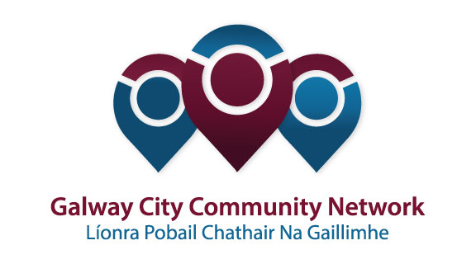
Tuairisc/Reporting Template for Galway City Community Network (GCCN) Reps

Please complete and email to info@galwaycitycommunitynetwork.ie
Cruinniú /Name of Meeting | Transport SPC
Ionadaí FPCG (glacadóir - nótaí)  Name of GCCF Rep (note-taker) | Niall Ó Brolcháin
Dáta & Suite  Date & Location of Meeting: | 29th January 2018
I láthair/ Attendance | In attendance  Derrick Hambleton – Community Rep  Niall Ó Brolcháin – Community Rep  Pat Hardiman – Union Rep  Cllr Frank Fahy  Cllr Noel Larkin  Cllr Peter Keane  Cllr Mike Cubbard  Cllr Collette Connolly  Cllr Mark Lohan
Príomhphointí pléite / Key Issues Discussed:

1. BRT Bus Rapid Transport was raised by myself.
2. Park and ride was raised by myself.
3. Speed limits in the city were raised by Collette Connolly.
4. Planning and leaving cars outside the City were raised by Derrick Hambleton.
5. Mike Cubbard and Peter Keane raised bus shelters and smart timetables.
6. Derrick Hambleton asked that all SPC reps be included in workshops. This was agreed.
7. Frank Fahy stated that public consultations should be in the areas they concern.
8. Tom Connell and Uinsinn Finn addressed the Galway City Centre Transport Management Plan
9. Cllr Cubbard raised issues of Road Safety.
11. Legal issues in relation to Coca Cola bike scheme have been resolved. Numbers have doubled over the last year.
12. There was a presentation made on the Strategic Work Plan and the Service Delivery Plan. I raised issues of measurement of progress in relation to Work Plan and the Service Delivery Plan. These should be aligned.

Socruithe déanta/ Key Decisions Made:

To have a presentation on the Connemara Greenway at the next SPC meeting.
Gníomhaíochtaí
Action(s) required from GCCN:

Follow up on Greenway presentation. Is the community sector involved in the SPC presentation or just the County Council?
Check with the Transport section that Community Reps are invited to the forthcoming City Transport workshops when they are arranged (March??) It may be helpful if linkage group members were also invited to attend.
Dáta don chéad chruinniú eile  Date of next meeting: | Friday 13th April
Moltaí breise /Any Other Comments:
None

