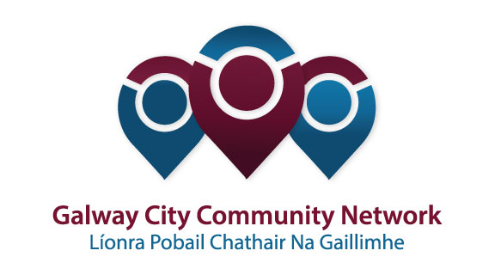
Tuairisc/Reporting Template for Galway City Community Network (GCCN) Reps

Please complete and email to info@galwaycitycommunitynetwork.ie
Cruinniú /Name of Meeting | Environment SPC
Ionadaí FPCG (glacadóir - nótaí)  Name of GCCF Rep (note-taker) | Caroline Stanley
Dáta & Suite  Date & Location of Meeting: | 29th Nov 2017
I láthair/ Attendance
Príomhphointí pléite / Key Issues Discussed:

Agenda
Times and Dates for next meetings
Pakman Award for Environment
Derelict Sites
Waste management /anti dumping presentation
Draft Bye Laws
Busking Bye Laws
Master Plans
Standing Orders /role of SPC Members

Socruithe déanta/ Key Decisions Made:
Accuracy of minutes updated
Times and dates for next years meeting agreed as stands
Derelict Sites to list all derelict sites that have come to council’s attention as we have only a short list while the council are currently dealing with 70-90 sites.
Anti-dumping Presentation from Environment , 83 houses do not have bins , approx. 45,000 spent on the Ballybane area, Merlin Woods dumping from households in Ballybane not dealt with . Agreed monitor areas which had been cleaned
Drafts Parks Bye Laws put forward to next meeting 371 submissions
Busking Bye Laws are at council level so not on our agenda
Development of Master Plans Terryland 2018
Merlin Woods 2019 , also discussed other parks such as Hunters , Barna
Salthill Promenade which is under the Dept of Marine
Discussions on the need for park employees , biodiversity officer tree Officer
Highlighted issues regarding illegal dumping , tree cutting that will need to be addressed as a matter of urgenct , anti-social behaviour.
Standing Order Section 71 brought up by Tom O Connell , stating operational matters don’t come under the SPCs but Eleanor pointed out this is a process of monitoring how policies are carried out within the council on a practical level
Hazardous waste may be collected bi-annually with a small fee charged for collection
Monitoring of skip waste ?
Public Prosecutions …Name and shame offenders
Energy Plan for Local Authority reduce energy waste inhouse , looking at lighting etc…
Presentation on Green Leaf by Arlene Finn , National Seminar 2018
Late February visit by Eu members

Gníomhaíochtaí
Action(s) required from GCCN:
How environment dept deals with those who don’t have waste collectors ? Where is there waste going
Action and engagement with council on master plans
Derelict Sites in the city
Engage with Energy Plan for Local Authority
Green Leaf

Dáta don chéad chruinniú eile  Date of next meeting: | 29th Nov 2pm
Moltaí breise /Any Other Comments:

