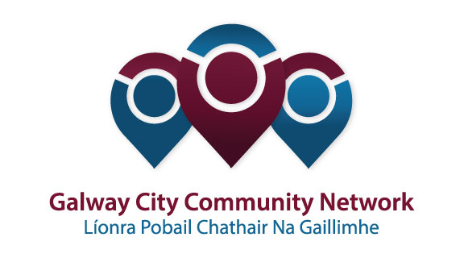
Tuairisc/Reporting Template for Galway City Community Network (GCCN) Reps

Please complete and email to info@galwaycitycommunitynetwork.ie

Cruinniú /Name of Meeting | Transport SPC meeting
Ionadaí FPCG (glacadóir - nótaí)  Name of GCCF Rep (note-taker) | Niall Ó Brolcháin
Dáta & Suite  Date & Location of Meeting: | 23rd October 2017
I láthair/ Attendance | John Walsh, Colette Connolly, Uinsinn Finn, Frank Fahy, Chris Coughlan, Derrick Hambleton, Anne Ruane, Pearce Flannery, Noel Larkin.

Príomhphointí pléite / Key Issues Discussed:

Brian Connolly of Bus Eireann made a presentation.
He said 10% of bus network in Galway City has bus lanes.
Bus frequency on Dublin road is now 6 minutes at peak times.
Briarhill is a key junction for bus eireann.
There is an issue of illegal parking at the bus stops in Eyre Square.
Park and ride services were raised.
404 route linked with 410 Newcastle to Eyre Square and on to Oranmore.
Question of why busses do not travel over the Quincentenary bridge was raised by 3 members.
Parking in the bus stops by cars was raised.
Integrated ticketing, real time system and time tabling with other operators was raised.
Light rail as an option was raised.
Imp busses were raised.
Bus corridor on Eglington Street was raised.
Agile solutions, overpasses and underpasses were raised.
School transport was raised. The NTA owns these services. The existing service gives good coverage. Dept of education is responsible for post primary network.
Contraflow lane for trucks at night for bus lanes was raised.
NTA owns electronic signage. City Direct can use those if they install the system on their busses.
Bus Rapid Transit had universal approval.

- Pearce Flannery raised the bike scheme in Galway and stated that the reasons it doesn’t work is location of bike sites and the weather.
- BRT system linking Knocknacarra / Salthill with Parkmore and Ballybritt was raised and supported by all members of the SPC. Brian Connolly said he would support this if it was efficient.
- There was a long discussion on Park and Ride. The airport site has been discussed in great detail. There is a commitment from the NTA to fund a Park and Ride site in the right location.
- Minutes of the last two meetings were agreed.
- Minutes of the special meeting were agreed.
- Bottlenecks on Foster Street and Eglington Street were raised.
- The issue of the sale of Ceannt station was raised. Opening up Ceannt station for greater use was raised.
- Legal issue with the Bike Schemes has been resolved. It was agreed that signage would be put in place at the Huntsman Bike Scheme site.
- Translations for the EIA for the ring road are underway.
- The draft SPC work programme for 2018 was circulated. The SPC agreed to hold a special meeting on 21st November at 12 noon to formulate a work programme.
- The issue of a presentation about the Connemara Greenway was raised. According to Uinsinn Finn the Greenway programme has now stalled. He also mentioned that there were a number of different Greenway groups in Galway. It was agreed that the Connemara group could present at the next ordinary meeting in January.

Socruithe déanta/ Key Decisions Made:
To take part in a special meeting on 21st November to agree on the work programme for the SPC.
Gníomhaíochtaí
Action(s) required from GCCN:
It would be useful if the linkage group could propose ideas of what to add to the agenda of the work programme.
Contact Connemara Greenway group to arrange presentation for next ordinary SPC meeting.

Dáta don chéad chruinniú eile  Date of next meeting : | 21st November 2017
Moltaí breise /Any Other Comments:

