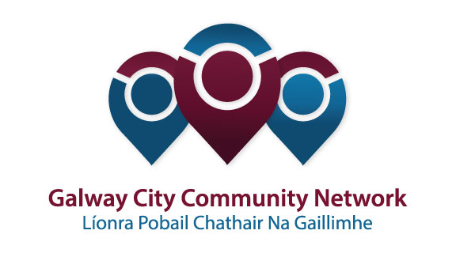
Tuairisc/Reporting Template for Galway City Community Network (GCCN) Reps

Please complete and email to info@galwaycitycommunitynetwork.ie
Cruinniú /Name of Meeting | Housing Strategic Policy Committee
Ionadaí FPCG (glacadóir - nótaí)  Name of GCCF Rep (note-taker) | Diarmaid O’Sullivan and Paul Hargaden
Dáta & Suite  Date & Location of Meeting: | Galway City Council. Thursday 19th October 2017
I láthair/ Attendance | Cllr. Declan McDonnell, Cllr Mark Lohan, Cllr. Mike Cubbard, Cllr. Niall McNeilis, Cllr Mairead Farrell  Patricia Philbin, Dermot Mahon, Sharon Lawless, Helena Martyn, Tom Prendergast, Cliona Clancy (All Galway City Council)  Diarmaid OSullivan, Paul Hargaden (Galway City Community Network) Alan Daly (ICTU)
Príomhphointí pléite / Key Issues Discussed:

Matters Arising
Outstanding rent accounts review to be completed by year’s end. A full review will be completed by next year.
GCC have met with a group with a view to establish a cooperative housing development in Galway – seeking a parcel of land. Department of Housing is looking to model the O’Cualann co-operative housing development in Ballymun Dublin in other parts of the country. Maintaining a good social mix is a key consideration.

Homelessness Update Galway City Council
Helena Martyn gave an update on homeless situation. 37 families currently in private emergency and transitional accommodation. Currently 16-20 rough sleepers. Number of individuals who do not meet the habitual residence condition has fallen. Cold weather response is being put in place with 21 beds in the COPE day centre with an additional 8 beds capacity in other location. It is proving very challenging to move families on from B&Bs so long term stays are likely. Regional Homeless Action Plan – included in the objectives in the plan will be a focus on Housing First and the establishment of Homeless Action Teams. HAT team to be established in Galway before Christmas.

Draft Strategic Plan for Housing Persons with Disabilities 2017
This plan was adopted by the SPC in April and recently went to full council . An amendment was proposed by Cllr Billy Cameron – ‘To ensure that the housing needs of people with disabilities in social and local authority housing are prioritised and when extensions are required that funding is applied for from Central Government by the Local Authority and that appropriate is supplied’ The proposed amendment was approved by the SPC.
There were 16 modifications to properties for people with disabilities in 2017. €600k worth of projects on-going.

Vacant Homes Strategy
Currently being developed for the city. CSO data suggest that there is a vacancy level of 9.3% in the city – (approx. 3000 properties.) Geo-directory information from An Post would suggest it is closer to 270 properties. GCC will be appointing a Vacant Homes Officer to negotiate with banks/owners of these properties to investigate if it is possible to repair, renew and but, purchase or purchase by CPO. Public can report vacant properties on www.vacanthomes.ie

Council Properties
Current turnaround time for void local authority properties is approximately 30 weeks. Vacancy rate is approximately 1.5%. There is funding in place for a scheme of boiler replacement as well as upgrading of doors and windows in local authority houses. Council want to move to a cyclical maintenance approach. In 2016 the council acquired 6 properties and in 2017 they have acquired 15 to date. Where RAS and HAP tenancies are being terminated for reason of sale, the council is looking to purchase the property to try to keep the tenant in place.

Capital Programme
Ballymoneen Road – 14 units under construction. To be completed by April 2018. Phase II is at design stage and will deliver a further 75 units. A part 8 planning application will go to the council in Q1 2018.
Ballyburke. 74 units will be delivered through PPP and is expected to be delivered in early 2020.

Council are developing a land management strategy. There are a number of sites under consideration currently including sites at Ballybane (old fire station), Monivea Road, Keeraun site on Ballymoneen Road. LIHAF (Local Infrastructure Housing Activation Fund) funds have been applied for to allow the development of the Bothar na Coiste site. Council looking to acquire 100 units through turnkey developments over the next 3 years. AHBs have approximately 200 units at various stages of development currently. Housing waiting list is currently 3,500+ when those on HAP, RAS and LTL are included.

AOB
ICTU will give a presentation at the next Housing SPC.
There was a call of a policy on illegal parking of traveller caravans on council lands/estates. Dermot Mahon explained the steps that are taken to deal with such occurrences. Traveller accommodation. Council currently looking at potential sites with proposals to be made by early next year possibly following the CENA model ( a site within a site).
Revised estate management policy will be discussed at next SPC. Director of Housing indicated that she would be happy to participate in the proposed workshop on homelessness planned by the PPN.

Socruithe déanta/ Key Decisions Made:

Gníomhaíochtaí
Action(s) required from GCCN:

Dáta don chéad chruinniú eile
Date of next meeting :
Moltaí breise /Any Other Comments:

