Public Notice
Draft Ardaun Local Area Plan

Notice is hereby given that Galway City Council, in accordance with Sections 18-20 of the Planning and Development Act 2000 (as amended), has prepared a Draft Local Area Plan for lands situated at the area known as Ardaun on the east side of the city.

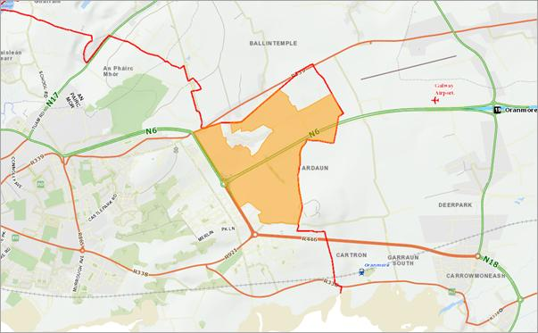
In compliance with the Strategic Environmental Assessment Directive (2001/42/EC) and the Planning and Development Strategic Environmental Assessment) Regulations 2004(as amended), Galway City Council has determined that Strategic Environmental Assessment is required and an Environmental Report has been prepared outlining the likely significant effects on the environment of implementing the Draft Local Area Plan.

Appropriate Assessment Screening pursuant to Article 6 of the EU Habitats Directive 92/43/EEC has been carried out and Galway City Council has determined that an Appropriate Assessment is not required.

The Draft Local Area Plan, Environmental Report and Appropriate Assessment Screening Report, is available for inspection from Thursday 7th September to Friday 20th October 2017 at the Planning Department, Galway City Council, City Hall, College Road, Galway and at the following locations:

Location Hours
The Cumasú Centre, Doughiska During normal opening hours
Ballybane Library During normal opening hours
Galway City Library During normal opening hours
Westside Library During normal opening hours
Knocknacarra Community Centre During normal opening hours

Documents can be also be viewed and downloaded at www.galwaycity.ie .

Submissions or Observations, with respect to the Draft Ardaun Local Area Plan, SEA Environmental Report and the AA Screening Report, can be made in writing to Galway City Council and will be taken into consideration by the Council before the making of the Local Area Plan.

Children or groups or associations representing the interests of children are entitled to make Submissions/Observations.

Submissions/Observations should be addressed to: Senior Planner, Planning Department, Galway City Council, City Hall, College Road, Galway or emailed to the following address, devplan@galwaycity.ie

The closing date for receipt of Submissions/Observations is 4pm on Friday 20th October 2017.

Written Submissions/Observations should be marked Draft Ardaun Local Area Plan and state the name of the person/body making the submission.

Public Information Session/Drop-in Clinic
Galway City Council will hold a public information session on Wednesday 27th September 2017 at The Cumasú Centre, Doughiska from 4.00pm to 8.00pm

A drop-in clinic will be held in the Planning Department every Thursday afternoon from 2.30pm to 4.00pm during the public display period. No prior appointment is necessary. Meetings can be arranged at other times subject to appointment.

If you have any queries, please contact the Development Plan and Policy Section, Planning Department, Galway City Council at 091 536822.

Dated: Thursday 7th September

Eileen Ruane
A/Director of Services,
Planning, Economic Development,
Community & Culture, Climate Change and Environment

